**Assignment -4**

Kubernetes / Docker

|  |  |
| --- | --- |
| Assignment Date | 19 September 2022 |
| Student Name | DEVANAND V |
| Student Roll Number | 7376191CS116 |
| Maximum Marks | 2 Marks |

**Question-1:**

1.Pull an Image from docker hub and run it in docker playground.

2.Create a docker file for the jobportal application and deploy it in Docker desktop application.

**Code:**

**app.py**

from flask import Flask

app = Flask(__name__)

@app.route('/')

def hello_world():

   return 'Hello World'

if __name__ == '__main__':

   app.run(debug=True,host="0.0.0.0")

**DockerFile**

FROM python:3.10.7

RUN mkdir /app

WORKDIR /app

ADD  . /app

COPY . /app

RUN python3 -m pip install -r requirements.txt

EXPOSE 5000

CMD [ "python3", "./app.py" ]

**Docker images**

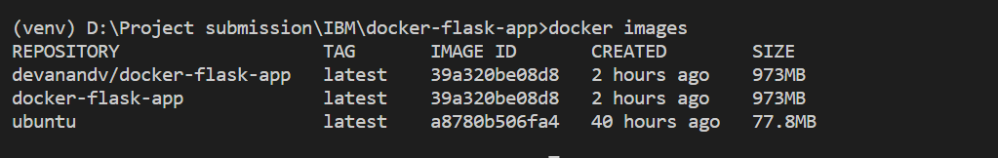

**Docker containers**

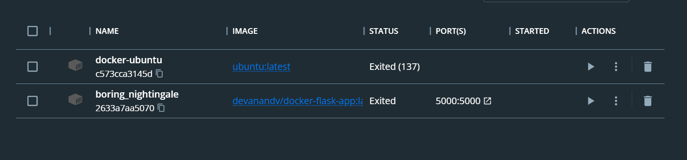

**Docker playground:**

Pulled the repository in docker playground.

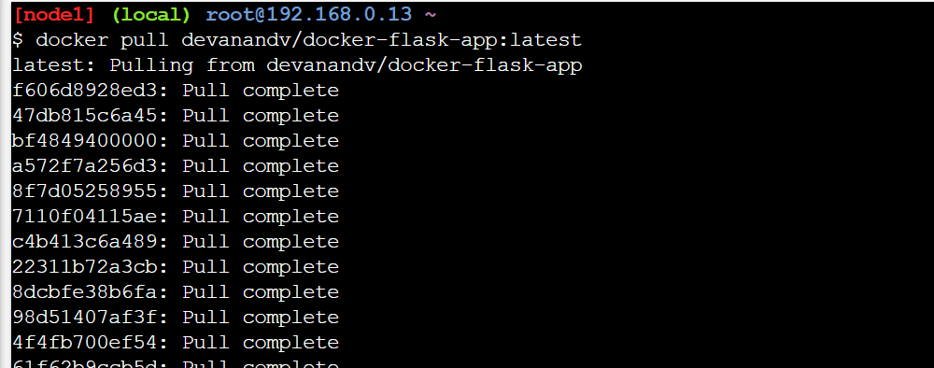

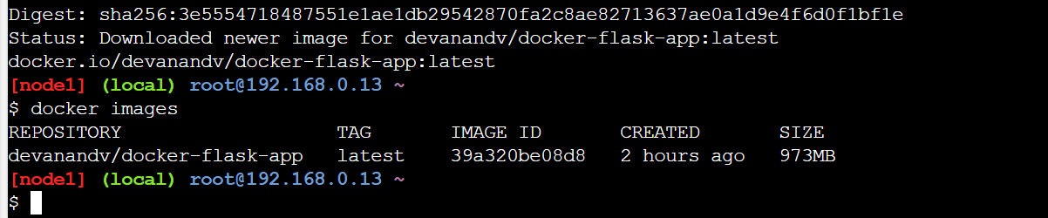

Running on the docker play ground

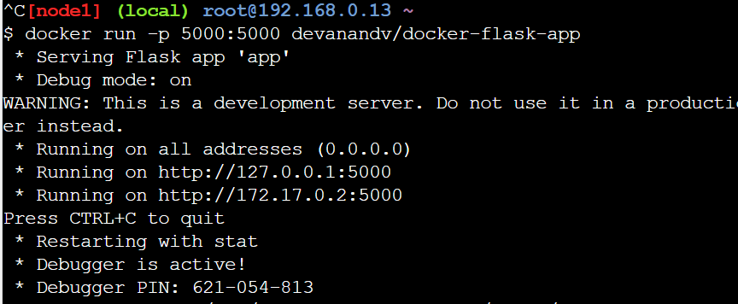

**Outpu:**

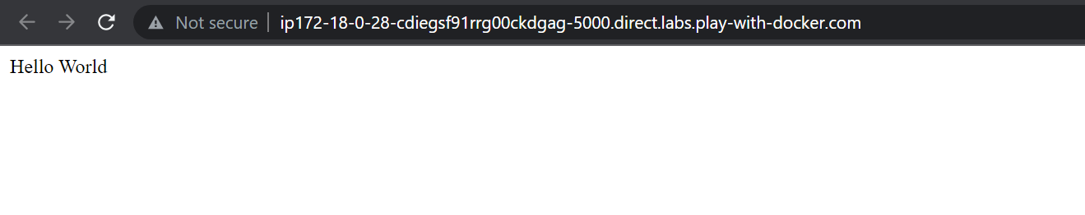

3.Create a IBM container registry and deploy helloworld app or jobportalapp.

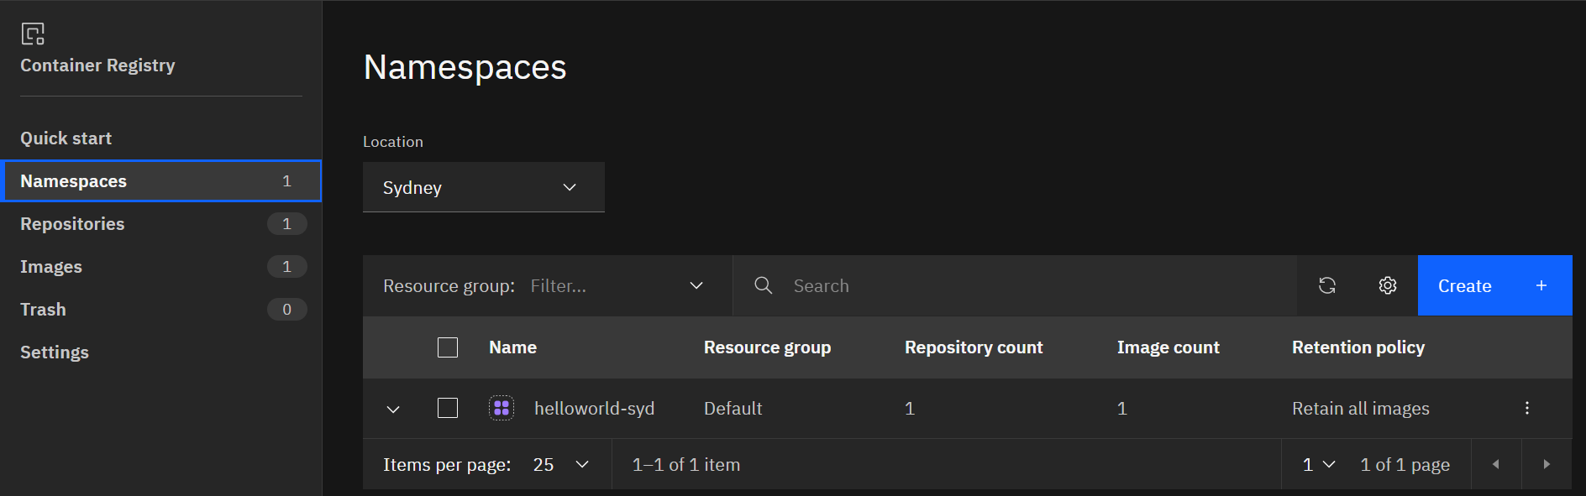

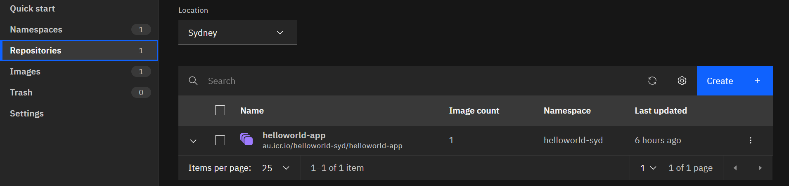

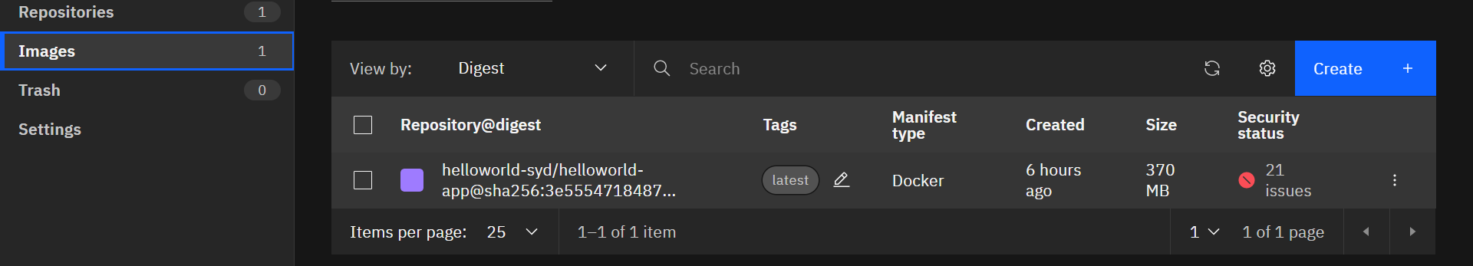

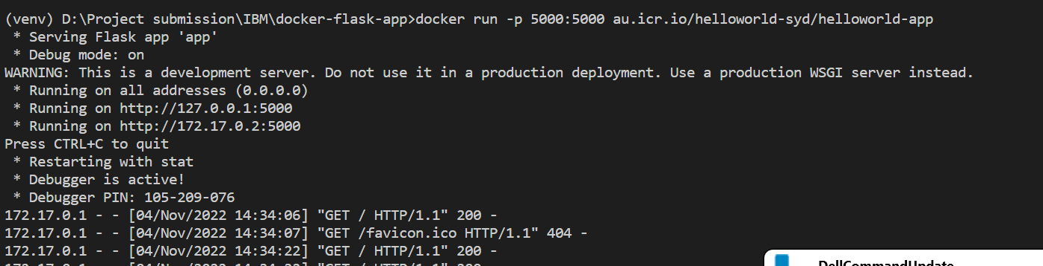

4.Create a Kubernetes cluster in IBM cloud and deploy helloworld image or

jobportal image and also expose the same app to run in nodeport.

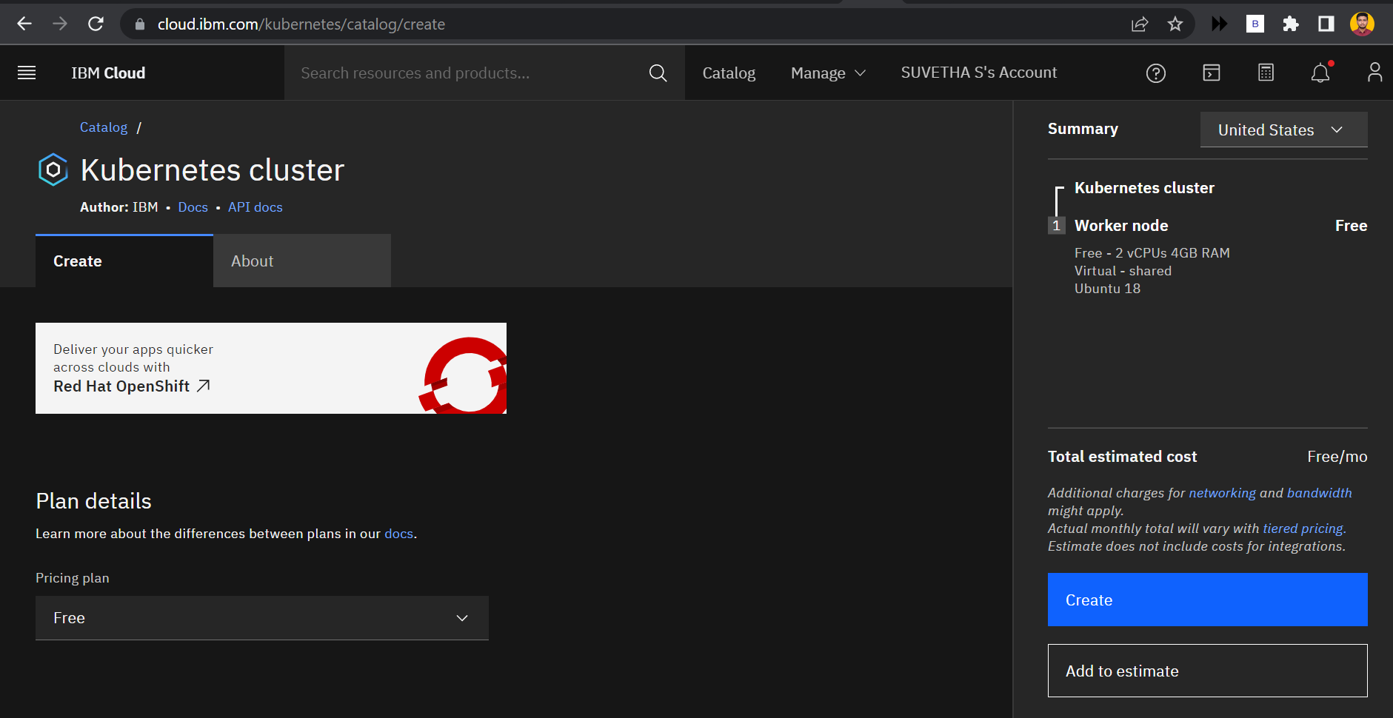

**Kuberneters cluster:**

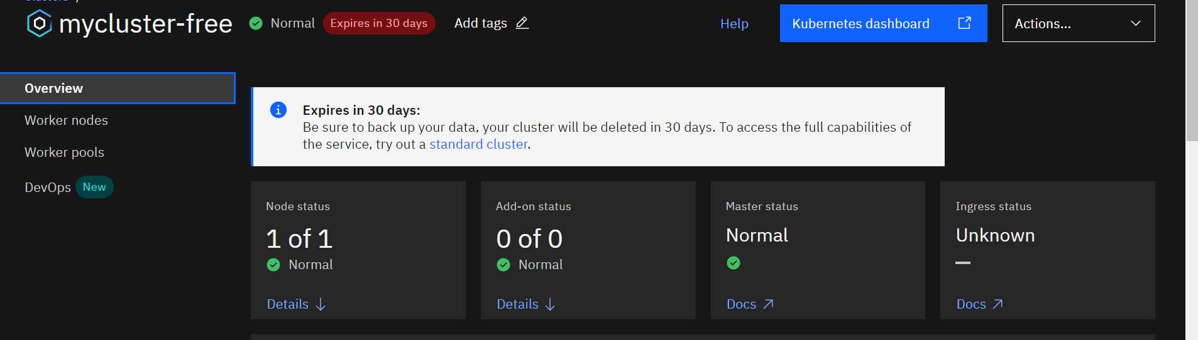

**Worker nodes:**

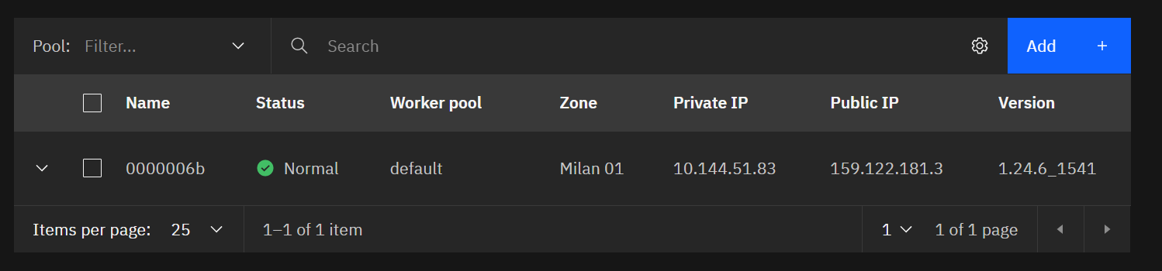

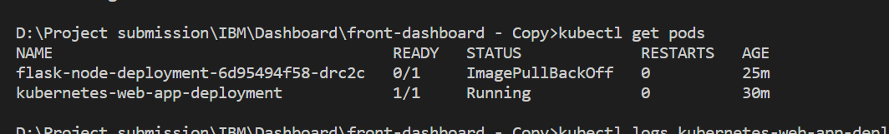

**Services:**

